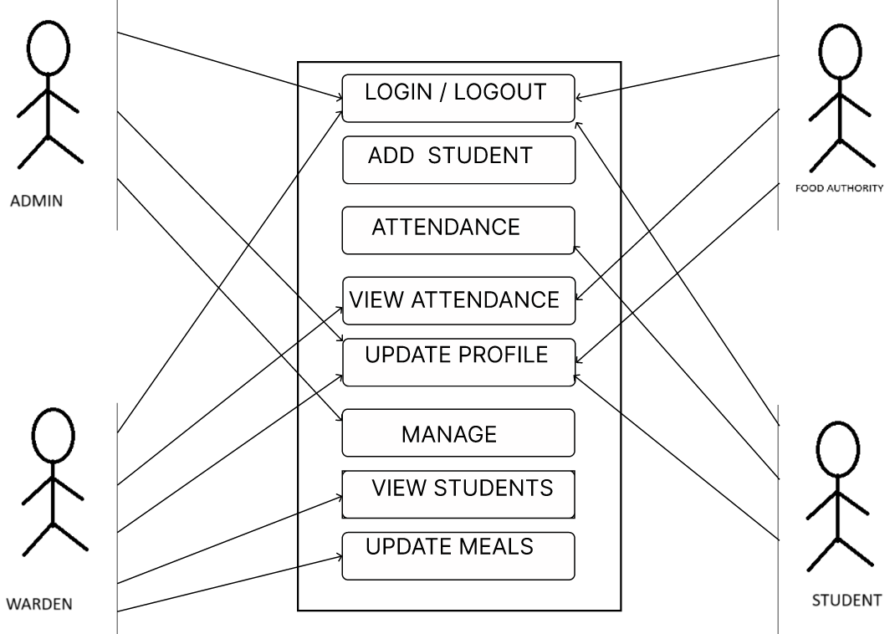

**USE CASE DIAGRAM**



**ADMIN MAIN PAGE**

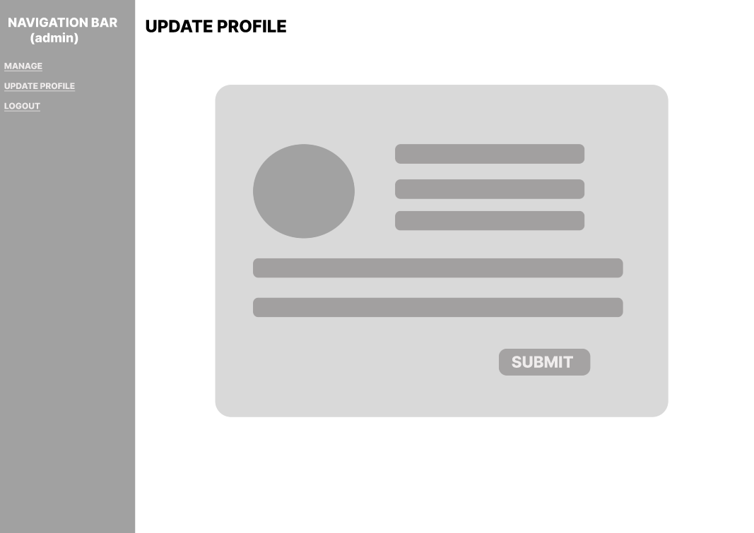

**ADMIN UPDATE PROFILE**

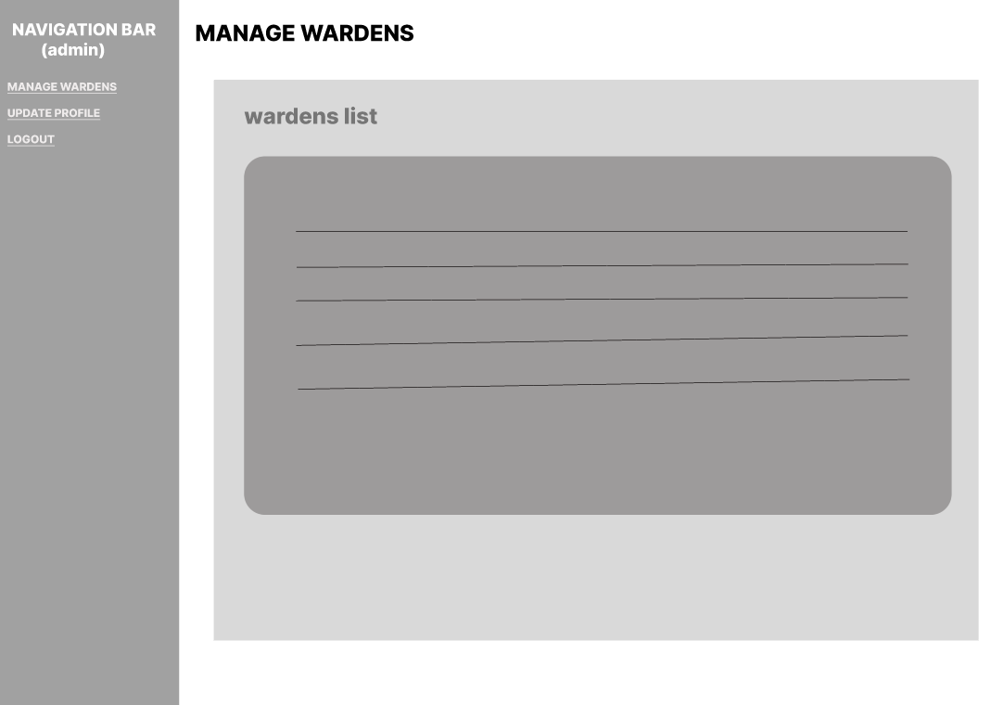

**MANAGE WARDENS**



**WARDEN MAIN PAGE**

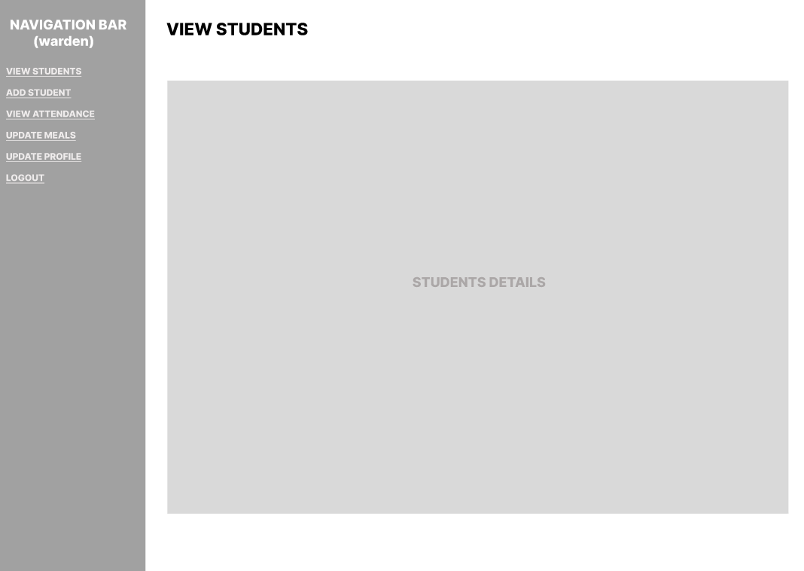

**VIEW STUDENTS**

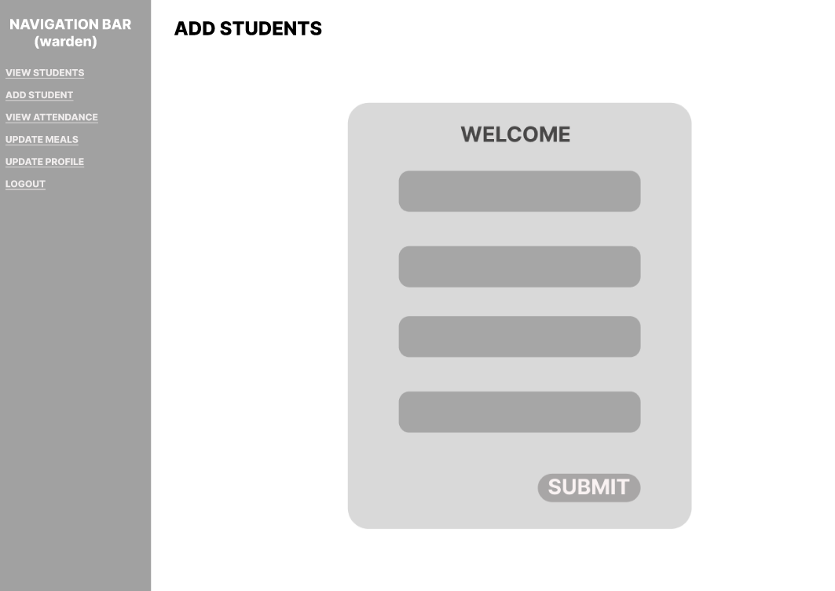

**ADD STUDENTS**

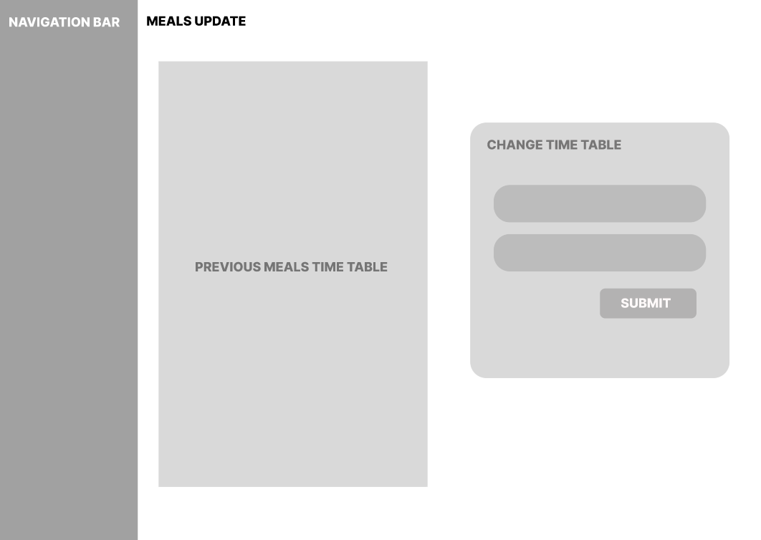

**MEALS UPDATE**